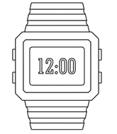

**PO3_DGW_Digital watch**

**(HSI)**

**Document status: Draft.**

| REVISION HISTORY | | | |
| --- | --- | --- | --- |
| VERSION | DESCRIPTION | Author | Date |
| 1.0 | Initial creation of document | Basma Abdelhakim Ahmed | 23/1/2020 |
|  |  |  |  |
|  |  |  |  |
|  |  |  |  |
|  |  |  |  |
|  |  |  |  |
|  |  |  |  |

Table of contents

1.Introduction 4

1.1 Purpose 4

1.2 System block diagram 4

2. Microcontroller specification 4

2.1 Pin Configuration Layout 4

2.2 Pins description 5

3. Character Liquid Crystal display specifications 5

4. Buttons specifications 5

5. Buzzer specifications 5

6. System features 5

Table of figures

**Figure 1** System block diagram…………………………………………………………………………………………………...4

**Figure 2** Microcontroller Pins configuration………………………………………………………………………………..4

**Figure 3.**OLED LCD schematic……………………………………………………………………………………………………..5

**Figure 4.** Tactical switch schematic…………………………………………………………………………………………....6

# 1.Introduction

## 1.1 Purpose

This document identifies all the Hardware Software Interface (HSI) data that reference

a digital watch described in PO3_DGW_Digital watch(CYRS) document.

## 1.2 System block diagram

liquid crystal display

Microcontroller

Button.1

# 

Buzzer

Button.2

Button.3

**Figure 1** System block diagram.

# 2. Microcontroller specification

The microcontroller used shall be 8-bit AVR microcontroller with 32Kbytes In-System

Programmable Flash.

## 2.1 Pin Configuration Layout

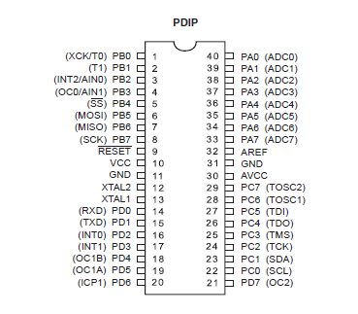

**Figure 2** Microcontroller Pins configuration.

## 2.2 Pins description

* **VCC**: Digital supply voltage.
* **GND:** Ground.
* **Port A (PA2...PA0):**
* Port A (PA2…PA0) shall serve as output pins.
* Port A (PA2…PA1) shall be used for interfacing data pins of Liquid Crystal display from (D0…D1).
* Port A (PA0) shall be used to interface buzzer.
* **Port D (PD2...PD0):**
  + Port D (PD2...PD0) shall serve as input pins.
  + Port D (PD2...PD0) shall be used to interface button.1, button.2 and button.3 relatively.

# 3. Liquid Crystal display specifications

The display used shall be OLED LCD LED.

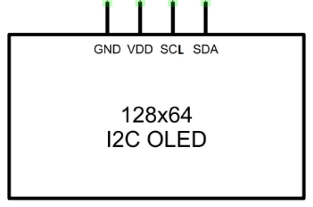

**Figure 3.**OLED LCD schematic.

# 

# 4. Buttons specifications

The buttons used shall be tactical buttons.

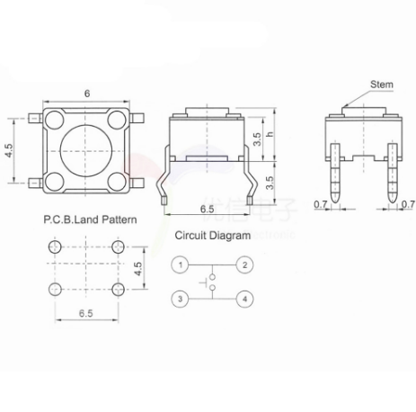

**Figure 4.** Tactical switch schematic.

# 5. Buzzer specifications

The buzzer used shall be an active buzzer.

# 6. System features

|  |  |
| --- | --- |
| Requirement ID | Requirement description |
| Req_ PO3_DGW_CYRS_02_V01#HW | The OLED LCD LED displayer shall be used to display the  the chosen mode interface according to the user’s choice. |
| Req_ PO3_DGW_CYRS_03_V01#HW | The active buzzer shall be used to notify the user when the alarm’s time hit. |
| Req_ PO3_DGW_CYRS_08_V01#HW | The tactical switches shall be used to switch between the three modes of the digital watch. |